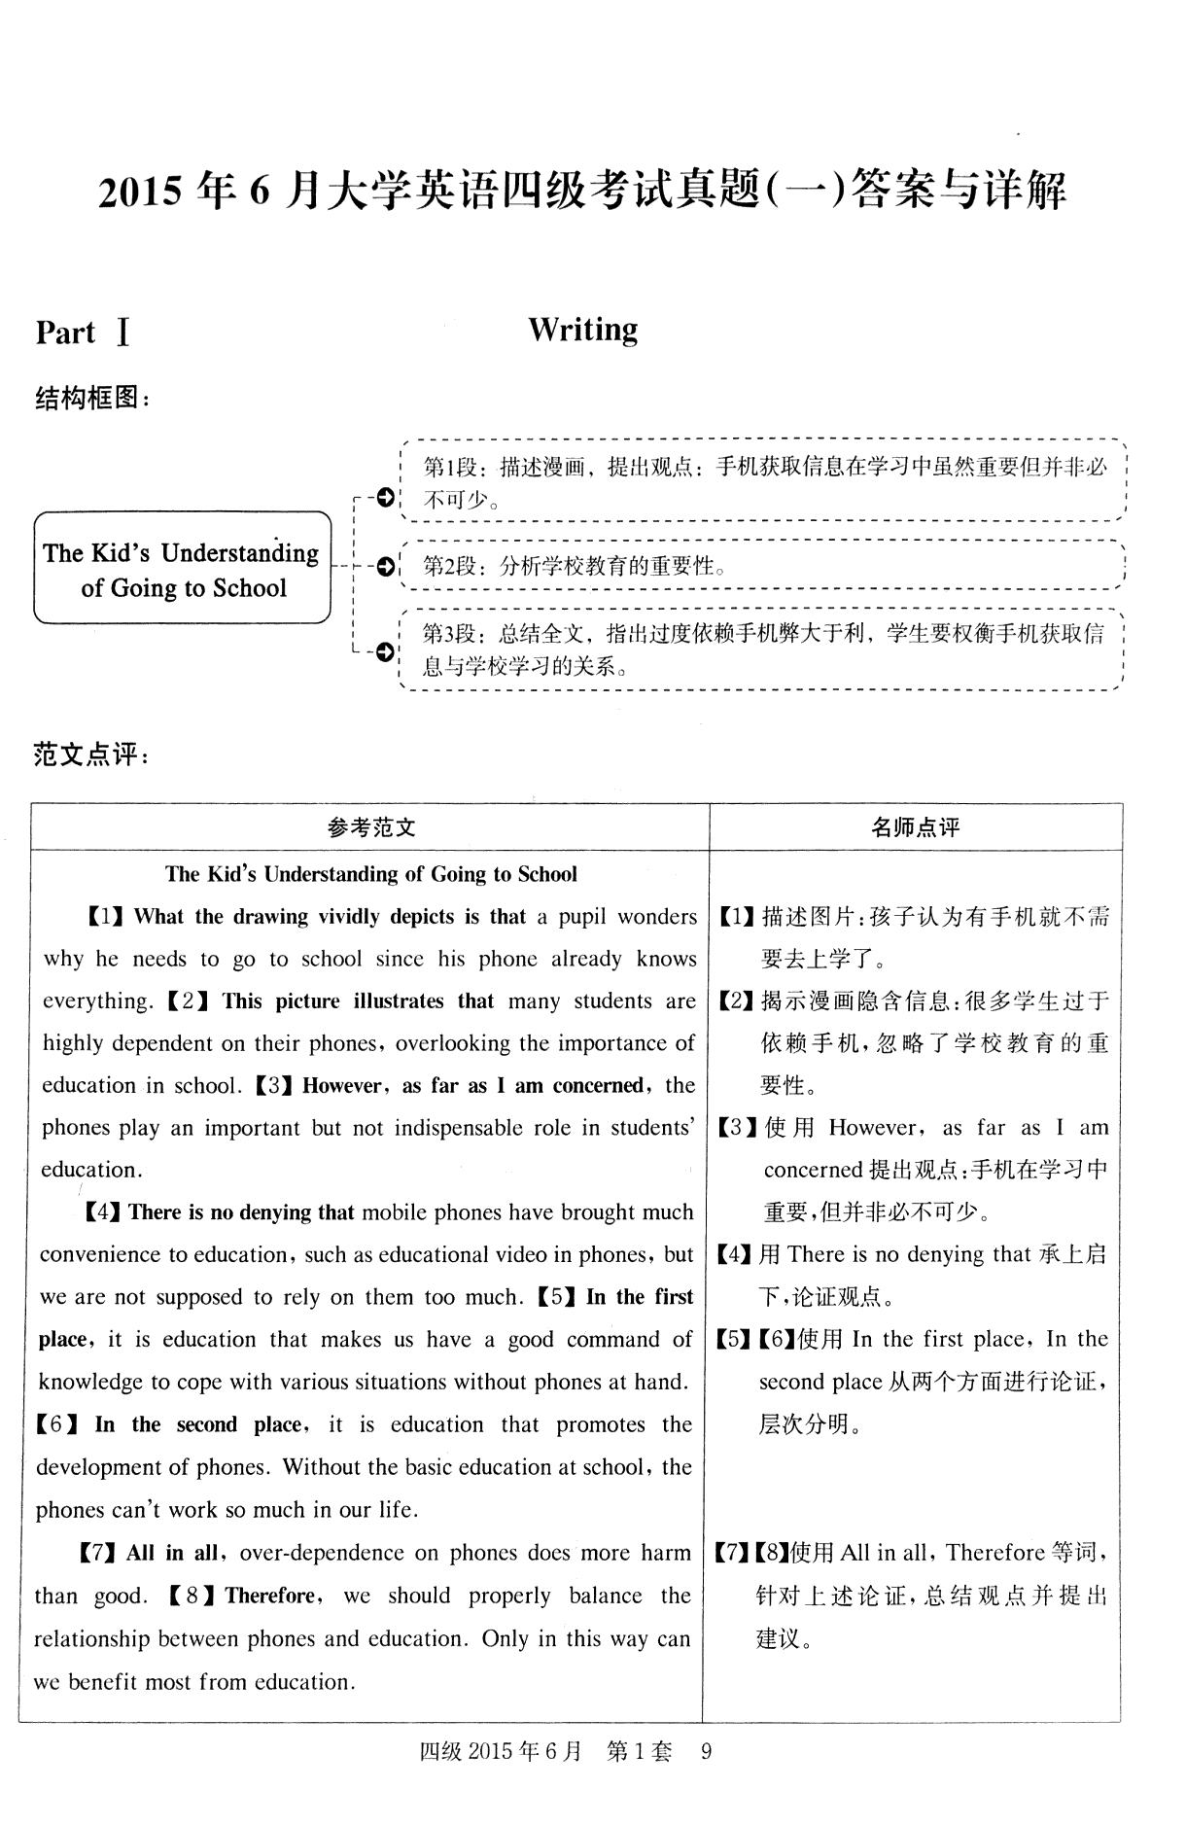

26-35 AKGLDHJOEC

36-45 KAGIBDEHFJ

46-50 BADCA

51-55 BBACD

